ML6 - Training vs. Testing

|  |  |  |
| --- | --- | --- |
| Jan Carlo D. Rabacca  11106344 | Suzette Dela Cruz  11118113 | Marc Janssen Chiu  11114525 |

# Introduction

The optimized logistic regression from the minFunc package introduces another method aside from implementing a lambda value in optimizing the gradient descent, the minFunc serves as the learning algorithm for optimization.

# Procedures

1. Follow the procedures available on the following link below.



1. On the procedure given, put the following code on the logistic_regression.m (see Fig.1).

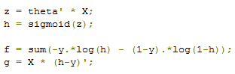

Fig. 1

1. There is an issue in ex1b_logreg.m, modify line 23 with the following code to fix it.



Fig. 2

# Data and Results

## Results

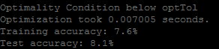

Fig. 3

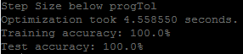

Fig. 4

# Analysis and conclusion

In this experiment, logistic regression is performed by implementing the minFunc instead of the usual lambda for learning algorithm to optimize the gradient descent, the logistic regression formula was vectorized to avoid using for loops to update the theta, in this manner the code would perform more efficiently and faster. In using the minFunc package alone, the training and testing accuracy was very low (see Fig. 3) and on the preliminary report, the training and testing accuracy was around 5 percent only, however, when the logistic regression was implemented by using the code on Fig. 1, the accuracy was improved to a 100 percent accuracy (see Fig. 4)

# REFERENCES

1. 2015. [Online]. Available: http://www.eecs.berkeley.edu/~russell/classes/cs194/f11/lectures/CS194%20Fall%202011%20Lecture%2004.pdf. [Accessed: 29- Sep- 2015].
2. GitHub, ''lbfgsAddC' undefined · Issue #3 · amaas/stanford_dl_ex', 2014. [Online]. Available: https://github.com/amaas/stanford_dl_ex/issues/3. [Accessed: 14- Oct- 2015].
3. 2015. [Online]. Available: http://cs229.stanford.edu/notes/cs229-notes1.pdf. [Accessed: 14- Oct- 2015].